

Deliverable 2

SYST17796 - Software Development

Guided under - Professor Amandeep Sindhu

Date of Submission: Wednesday, March 25, 2020

Group Members: Steven ( Group Leader), Jasmine

Daniel and Zawad

Content

Cover page 1

Content page 2

Project Background 3

Use Cases 6

UML Class Diagrams 7

Project Background

As mentioned in Deliverable 1 the object of the game is to be the first player to get rid of all the cards in hand wins. Rules are pretty simple, cards have to match the top discard in color or number can be played into the pile or choose to play a wild card.

The sub-objectives of playing game and participating in activities is to learn problem-solving,strategy,trust and calculated risk taking.the rule of the game can have far reaching positive effects when they are applied to real life situations

We have introduced new variables to maintain a control in the game like,

Timer - which will be initialised to 20 seconds whenever a new move is about to be played. If the timer runs out before playing the move, the player will be penalised.

Count - with this the game will count the remaining cards in the deck and every player will have a card count variable. Whichever becomes 0 first the game will end.

Keeping the OOD principles in mind, we tried to design and write an efficient code for our game. We created classes which are tightly cohesive and loosely coupled so that if a change needed to be done the code will not be affected. We extended from the base code to show the inheritance principle and specific methods are created to perform certain tasks to display delegation across our code.

In this document, we have added the UML Use cases(the list of task our game can do), Code Mine diagram(how the flow function of our game) and UML Class diagram of our updated code and showing the relationship among the classes.

Our repository link : <https://github.com/skebila/SoftDev-Deliverable/tree/master/Deliverable-2>

UML USE CASE

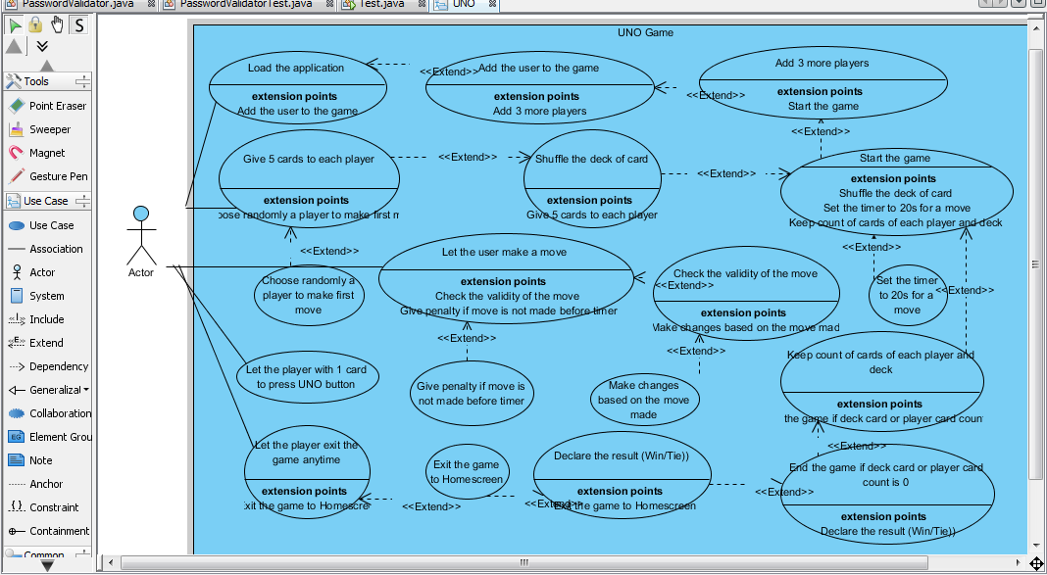

UML Class Diagram

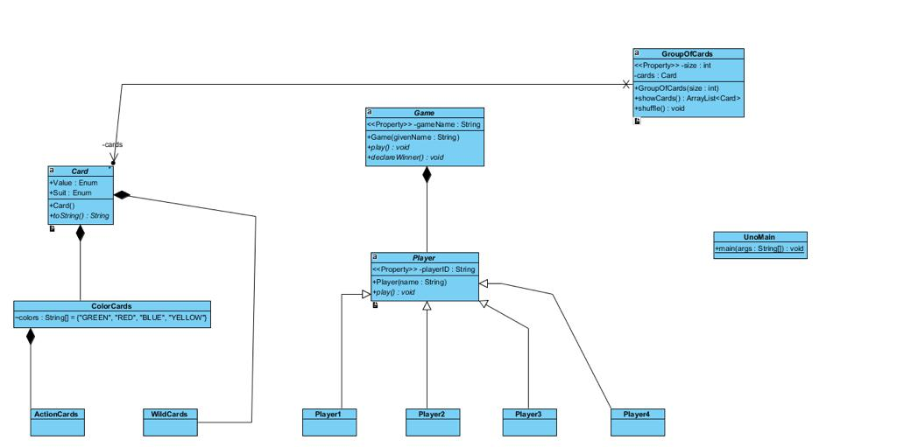

UNO cards are of different type of cards. The primary color cards are green, red,yellow and blue. Color cards have number cards and action cards.

Apart from color cards there are wild cards.

Both the wild cards and color cards are children from uno cards. And all the cards are compostion to the Card class

Player class have a composition relationship with the game class as without the players game will not exist.

Code Mine Diagram

